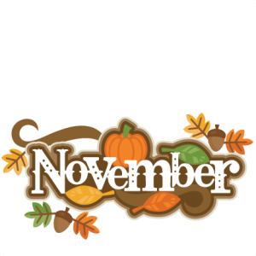****



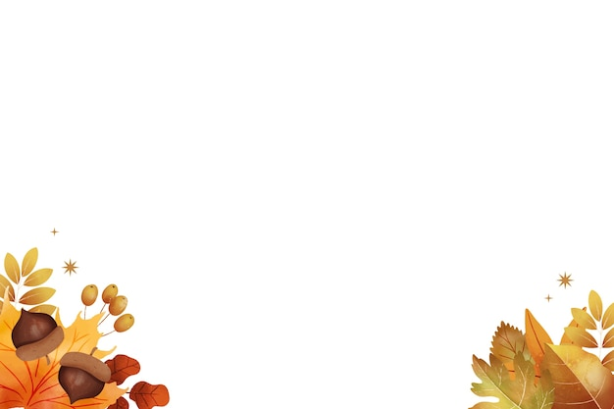**Monday Tuesday Wednesday Thursday Friday**

|  |  |  |  |  |
| --- | --- | --- | --- | --- |
|  |  |  |  | ***1***  Breaded Fish Sandwich  Tater Tots  Cauliflower  Fruit Salad |
| ***4***  Cold Sandwich Platter w/ Ham Cheese  Winter Blend Veg  Mandarin Oranges | **5**  Sausage Pizza  Green Beans  Red Apples | **6**  Meatball Marinara on Bakery Roll  Canned Pears  Vegetable Blend | ***7***  Chicken Quesadilla  Refried Beans  Watermelon  Peas and Carrots | ***8***  Swedish Meatballs over Noodles  California Blend  Canned Peaches |
| ***11***  Grilled Ham & Cheese Sandwich  Baked Beans  Pineapple  Green Beans | ***12***  Baked Chicken Nuggets  Corn  Waffle Fries  Fresh Fruit | ***13***  Chicken Patty on Bun  Cauliflower  Fruit Salad  Citrus Jell-O | ***14***  Cheeseburger Pasta Casserole  Asparagus  Fruit Cocktail | 15  Waffles w/ Fresh Fruit  Sausage Links  Applesauce |
| ***18***  Cold Sandwich  Platter w/ Ham & Cheese  Fruit & Yogurt  California Blend Veg | ***19***  Sweet & Sour Chicken w/ Rice  Mixed Vegetables  Applesauce  Dinner Roll | **20**  Fish Nugget Macaroni & Cheese Peas & Carrots Fruit Salad | ***21***  Grilled Turkey & Cheese Sandwich  Tomato Soup w/ Goldfish.  Cut-up Fruit | ***22***  BBQ Chicken  Mashed Potatoes  Broccoli  Tropical fruit  Dinner Roll |
| **25**  Pepperoni Pizza  Green Beans  Red Apples | **26**  Chicken Soft Taco w/ Lettuce and Tomato and Refried Beans  Fresh Fruit | ***27***  Sloppy Joes w/ Bun  Peas  Sweet Potato FF  Fruit Salad | ***28***  ***Happy Thanksgiving*** | ***29***  Hamburger on Bun  Sliced Cucumbers w/ Ranch  Broccoli  Bananas |

**Milk is served with lunch**

**Water is offered throughout the day**